Research Seminar – Financial Institutions

Proposed steps – 25.03
- Clean dataset
- Include the right macro control variable for GDP per capita
- Potentially: Prepare age_85 control variable
- Potentially: Winsorize some bank control variables

- Run regression to find final specification
- Run cross-sectional regression (time FE only, but including interaction term) again for full sample
  - Run it for EU27 + CH only, but cluster by Country_Region
  - Run it for Saving Banks only
  - Run it step-by-step bottom-up to include more countries
  - Split by financial system type and run wild-cluster bootstrap for both due to small sample bias
  - Potentially: Aggregate by country and run regression model again
  - Define: What are our key Hypotheses that are tested?

- Goal: Find the right specification for each hypothesis

Merging notes – 23.03.2026

Merging procedure: https://chatgpt.com/s/t_69c10b56c8348191a7d836bd228ce1ae

Country_Region: idea is to create a new column called “Country_Region”, where we add a new variable consisting of the country and the region (format country_region, ex. USA_New York) if the region is available, otherwise just the country (ex. Finland --> Finland) - we only do it for Germany and USA. Goal is to have more clusters for our clustered standard errors:
- Relevant documents:
  - Savings Banks
    - Germany_country-region_SAV.csv
    - USA_country-region_SAV.csv
  - Non-Savings Banks
    - USA_country-region_BANK.csv
- Procedure:
  - Take “Region” from each file and merge on “Entity.ID” with "SP_COUNTRY_NAME”

FinStucture & Age65: expanding dataset with FinStructure and Age65 variables for OECD countries (excluding already existing EU27+CH)
- Relevant document:
  - fin_structure_OECD_patched.csv
- Procedure:
  - Take variables: “mktcap_pct_gdp”, “pvcredit_pct_gdp”, “FinStructure”, “pop65_pct” and merge with dataset on “SP_COUNTRY_NAME” and “fiscal_year”

Meeting – 11.03.26
Notes:
- Agreed on using bank/market as main variables for H1
- Controls – pension system: explaining pension system from different angles
  - pension categories
  - reclassification ratio
  - death gap

Tasks
- GB
  - Individual master for control variables
    - Pension system 1-3
    - Replacement rate
    - FinDevelopment
    - Age65
- Alex
  - Data cleaning
- Noel
  - Slides
  - Check Macro and Banking control variables
- Check overleaf

Comments GB on variables/data cleaning process:

FinStructure: internal note – there are two datasets, one “as-is” meaning with only numbers sourced from World bank, the other includes numbers sourced from ECB – to be honest they’re quite close.. We can run both and see if it works, if it doesn’t then let’s stick with smaller panel (World Bank)
Links:
World Bank
- Market capitalisation (CM.MKT.LCAP.GD.ZS): https://data.worldbank.org/indicator/CM.MKT.LCAP.GD.ZS
- Private credit by banks (FD.AST.PRVT.GD.ZS): https://data.worldbank.org/indicator/FD.AST.PRVT.GD.ZS
ECB Statistical Data Warehouse
- Market capitalisation (listed shares): https://data.ecb.europa.eu/data/data-categories/financial-markets-and-interest-rates/securities-issues/securities-issues-statistics-csec/listed-shares
Eurostat
- GDP and main components (nama_10_gdp): https://ec.europa.eu/eurostat/databrowser/view/nama_10_gdp__custom_20531132/default/table
BIS Total Credit Statistics
- Switzerland — private credit by banks 2017–2024: https://data.bis.org/topics/TOTAL_CREDIT/BIS%2CWS_TC%2C2.0/Q.CH.P.B.M.770.A?view=observations
Nasdaq OMX Stockholm
- Sweden — market capitalisation % of GDP: https://www.nasdaq.com/european-market-activity/news/statistics

The FinStructure variable is constructed following Levine (2002) as the natural logarithm of the ratio of stock market capitalisation to private credit by banks, both expressed as a percentage of GDP, with a (1+) adjustment in numerator and denominator to ensure the log is well-defined. The primary data source is the World Bank's World Development Indicators (indicators CM.MKT.LCAP.GD.ZS and FD.AST.PRVT.GD.ZS). Where World Bank data is unavailable for recent years, we supplement with data from the ECB Statistical Data Warehouse for market capitalisation — dividing absolute values by nominal GDP from Eurostat (nama_10_gdp) to obtain percentage of GDP figures — from the BIS Total Credit Statistics for Swiss private credit over 2017–2024 (Credit from Banks, domestic to Private non-financial sector, percentage of GDP, adjusted for breaks), and from Nasdaq OMX Stockholm for Swedish market capitalisation as a percentage of nominal GDP. As the BIS series exhibits a systematic level difference relative to the World Bank in overlapping years, a correction factor equal to the average gap is applied. Ireland is excluded due to large discrepancies between World Bank and ECB market capitalisation figures, attributable to well-known multinational distortions in Irish national accounts. EU member states not covered by either source are also excluded. The resulting panel is unbalanced.

PensionSystemClassification: With Denmark and Ireland excluded, the Beveridgean group shrinks to only 3 countries (Finland, Sweden, Netherlands), making it difficult to precisely identify a separate coefficient. A single Bismarckian dummy (1 = Bismarckian, 0 = otherwise) would be statistically more robust. Worth discussing with the group whether the Beveridgean vs Multipillar distinction is theoretically important enough to justify keeping two dummies
Pension systems are classified following Ebbinghaus (2021), Werding (2003), and OECD Pensions at a Glance (2024) into three categories: Bismarckian systems (earnings-related, contribution-based, dominant in Continental and Southern Europe), Beveridgean systems (flat-rate, universal, tax-funded, dominant in Nordic countries), and Multipillar/Mixed systems (combination of public mandatory and private funded pillars). We encode this classification using two dummy variables — Bismarckian and Beveridgean — with Multipillar as the baseline category.

AggregateReplacementRatio:
The aggregate replacement ratio is defined as the gross median individual pension income of the population aged 65–74 relative to the gross median individual earnings of the population aged 55–64. Following Scharfstein (2018), who documents that higher public pension replacement rates are associated with more bank-based financial systems and greater household deposit holdings, and Bottazzi, Jappelli and Padula (2006), who show that pension generosity substitutes for private wealth accumulation, we use this variable as a proxy for the generosity of public pension systems across countries. Data are sourced from Eurostat (dataset tespm100) and cover EU-27 member states plus Switzerland over 2010–2025.

Age65:
The share of the population aged 65 and above (% of total population) is sourced from the World Bank's World Development Indicators (indicator SP.POP.65UP.TO.ZS) for EU-27 member states plus Switzerland over the period 2010–2025. This variable serves as the primary measure of population aging in our analysis. Following Doerr, Kabaš and Ongena (2024) and Avramidis and Pennacchi (2025), we use the broad elderly population share as the key driver of retail deposit inflows, rather than a narrower age cutoff, as both papers demonstrate that the 65+ threshold most robustly captures the relationship between demographic aging and bank deposit funding. From a life-cycle perspective, individuals above retirement age tend to hold a disproportionately large share of their wealth in liquid deposit accounts, either as a precautionary buffer or pending bequest decisions, making this age group the primary source of retail deposit supply at the banking system level. The data require minimal cleaning — country names are matched to our EU-27 + Switzerland definition and the dataset is reshaped from wide to long format with one observation per country-year.

Regression Notes – 16.03.26 - GB

Full Methodology Guide — Your Paper

The Identification Story (Write This First)
Before any equation, your paper needs one clear paragraph explaining where your variation comes from. Here it is, drafted for you:
"We exploit variation in population aging and financial system structure across 28 European countries over 2010–2024 to identify their effect on savings bank deposit funding. Our main independent variables — the share of population aged 65+ and the Levine (2002) financial structure index — vary at the country × year level and are assigned to all savings banks operating within that country-year. The 2010–2024 window is particularly suited for this analysis: it captures a structural shift in European financial systems following the Global Financial Crisis, during which several previously bank-based systems moved meaningfully toward market-based intermediation, generating within-country variation in FinStructure that supplements the well-documented cross-country heterogeneity."
This paragraph does three things at once: justifies the sample period, explains your identifying variation, and pre-empts the reviewer question about whether FinStructure is just a cross-sectional variable.

The Five-Model Regression Sequence
Your equation at the bank level is:
DepositRatio_ict = α + β₁·Age65_ct + β₂·FinStructure_ct + β₃·(Age65 × FinStructure)_ct + β₄·ARR_ct + β₅·DeathGap_ct + β₆·Bismarckian_c + β₇·Beveridgean_c + γ·BankControls_it + δ·MacroControls_ct + μ_i + λ_t + ε_ict
Where i = bank, c = country, t = year.
Your five models map precisely to this as follows:
Model 1 — Baseline aging: β₁ only, no fixed effects, no controls. This is your raw OLS. It will almost certainly be upward biased due to omitted variables, but it establishes the unconditional correlation and gives reviewers a benchmark.
Model 2 — Add FinStructure and interaction: Add β₂ and β₃. This is your primary hypothesis test. β₃ is the coefficient you care most about for H1 — it tells you how the aging-deposit relationship shifts as the financial system becomes more market-based. The expected sign is negative: aging matters more positively for deposits in bank-based systems.
Model 3 — Add pension controls: Add β₄ (ARR), β₅ (DeathGap), β₆ and β₇ (pension system dummies). Note that Bismarckian and Beveridgean are dummies with Multipillar as baseline, exactly as your PPT specifies. ARR and DeathGap are time-varying; the pension dummies are time-invariant at country level — this matters when you add fixed effects in Model 5.
Model 4 — Add bank and macro controls: Add γ (bank controls) and δ (macro controls). This is where you absorb the main omitted variable concerns flagged in your PPT slide 11.
Model 5 — Full model with fixed effects: Add bank fixed effects μ_i and year fixed effects λ_t. This is your preferred specification. Present it as such explicitly.

Fixed Effects — Precise Implications for Your Variables
When you add bank FE + year FE in Model 5, here is exactly what happens to each variable — you need to understand this before your professor meeting:
Bank FE (μ_i) absorbs everything constant within a bank over time: country membership, ownership type, business model, whether it's a pure retail savings bank or a more diversified thrift. This is good — it removes a huge source of omitted variable bias.
Year FE (λ_t) absorbs everything common to all banks in a given year: ECB policy rate changes, the 2012 sovereign debt crisis, post-2015 negative rate environment, COVID. This is also good and largely replaces the need for an interest rate macro control (though you should still include it as a robustness check and your professor may ask for it).
The pension system dummies (Bismarckian, Beveridgean) are time-invariant at country level and will be perfectly collinear with bank FE and therefore dropped automatically in Model 5. This is expected and fine — report them in Models 3 and 4 without FE, then note they are absorbed in Model 5. This is standard practice and papers like Scharfstein (2018) deal with it the same way.
ARR and DeathGap are time-varying at country level, so they survive bank FE. They are identified from within-country changes in replacement ratios over time, which is plausible given the pension reforms many EU countries implemented post-2008.
FinStructure is time-varying at country level and survives bank FE — identified from the post-GFC convergence toward market-based systems you described. This is your key justification for why the interaction term is still estimable in Model 5.

Bank Controls — What the Literature Uses and Why
Based on Doerr et al. (2022) and Avramidis & Pennacchi (2025), the standard bank-level controls for a deposit funding regression are:
Log(Total Assets): Controls for bank size. Large savings banks have more access to wholesale funding and may rely less on retail deposits as a share of assets. Expected sign on deposit ratio: ambiguous or negative. This is your most important bank control.
Loans/Assets (loan ratio): Banks with more loans on the asset side need stable funding — retail deposits are the natural match. Expected sign: positive. Avramidis & Pennacchi (2025) include this explicitly.
Equity/Assets (capital ratio): Better capitalized banks face less pressure to chase retail deposits for funding stability. Expected sign: negative or ambiguous.
Net Income/Assets (ROA — profitability): More profitable banks have stronger reputations and may attract deposits passively. Expected sign: positive.
All four are constructable from your SNL variables (Total Net Loans, Total Equity, Total Assets, Net Income Before Taxes). I'd recommend including all four in Model 4 and 5, then testing sensitivity by dropping them one at a time.

Macro Controls — What to Collect and From Where
For a master's seminar paper, two macro controls are sufficient and defensible:
Real GDP growth (country × year): World Bank WDI indicator NY.GDP.MKTP.KD.ZG. This addresses the concern from your PPT that aging might proxy for economic development. In R, the WDI package pulls this directly.
Short-term interest rate (country × year): ECB Statistical Data Warehouse for eurozone countries; for non-euro countries (Denmark, Sweden, Poland, Czech Republic, Hungary, Romania, Bulgaria, Croatia, Switzerland) use national central bank rates or the OECD MEI database. Alternatively, Eurostat table irt_st_a gives harmonized short-term rates. Interest rates matter because low/negative rates post-2015 compressed deposit margins and may have structurally changed deposit behavior. Year FE will absorb the common rate shock, but country-level rate variation (e.g., Sweden vs. Italy) is not absorbed.
When you meet your professor, flag these two specifically and ask if she wants inflation as a third macro control. Some papers include it, others don't.

Standard Errors — The 28-Cluster Problem
This is the issue you need to raise explicitly with your professor. Here is the precise problem and solution:
Since Age65, FinStructure, and ARR all vary at country × year, all banks within Germany in 2018 receive identical values for these variables. Their residuals are therefore mechanically correlated. Standard errors that ignore this are severely underestimated, producing spuriously significant t-statistics.
The solution is to cluster at the country level. In R with fixest (which is what you should use — it's the fastest and most flexible package for this):
r
library(fixest)
model5 <- feols(
Deposit_Ratio ~ Age65_pct * FinStructure + agg_replacement_ratio +
DeathGap + log(Total_Assets) + Loan_Ratio + Equity_Ratio + ROA +
GDP_growth + interest_rate | Entity.ID + fiscal_year,
data = your_data,
cluster = ~SP_COUNTRY_NAME
)
The 28-cluster caveat: Asymptotic cluster-robust SEs require roughly 30–50 clusters to be reliable (Cameron & Miller 2015, Journal of Human Resources). With 28 countries you are just below that threshold. The technically correct solution is the wild cluster bootstrap (Cameron, Gelbach & Miller 2008), available in R via the wildboottest package or directly in fixest via boot_se. For a master's paper, raise this with your professor — she may say clustered SEs are sufficient at this level, which is a reasonable position. But knowing the argument shows methodological maturity.

Diagnostic Tests to Run (and Report)
Here is the exact sequence in R, with what each test tells you:
1. Hausman test (FE vs RE):
r
library(plm)
fe_model <- plm(Deposit_Ratio ~ Age65_pct + FinStructure,
data = your_data, index = c("Entity.ID","fiscal_year"),
model = "within")
re_model <- plm(Deposit_Ratio ~ Age65_pct + FinStructure,
data = your_data, index = c("Entity.ID","fiscal_year"),
model = "random")
phtest(fe_model, re_model)
Expected result: reject null → use FE. Almost certain given bank heterogeneity.
2. Cross-sectional dependence (Pesaran CD test):
r
pcdtest(fe_model, test = "cd")
If significant, it means common shocks are creating cross-bank correlation beyond what year FE absorbs. Year FE largely handles this, but report the test result.
3. Serial correlation (Wooldridge test):
r
pbgtest(fe_model)
Almost certainly present — deposit ratios are persistent. Clustered SEs address this, but document it.
4. VIF for multicollinearity: Run on Model 4 (before FE, so you can actually compute it). The key pair to watch is Age65 and FinStructure — if countries that are old are systematically bank-based, their correlation will inflate standard errors on β₁, β₂, and especially β₃.
5. Panel unit root (Im-Pesaran-Shin test):
r
library(plm)
purtest(your_panel$Deposit_Ratio, test = "ips", exo = "intercept", lags = "AIC")
purtest(your_panel$Age65_pct, test = "ips", exo = "intercept", lags = "AIC")
If Deposit_Ratio is I(1) (non-stationary), your regression is spurious unless the variables are cointegrated. Demographics trend upward and deposit ratios may also trend — test this and report it. For a master's paper, if you find non-stationarity, first-differencing or including a time trend is a defensible response.

Descriptive Statistics — What Your Table 1 Must Show
Three things to include before any regression table:
Panel A — Summary statistics: Mean, SD, min, max, N for all variables. Split by bank-based (FinStructure < 0) vs. market-based (FinStructure ≥ 0) countries and test whether means differ significantly. This visually motivates your H1.
Panel B — Within vs. between variance decomposition: For each continuous variable, report how much variation is within-bank over time vs. between banks. In R:
r
library(plm)
pd <- pdata.frame(your_data, index = c("Entity.ID", "fiscal_year"))
summary(pd$Age65_pct) # gives between and within SD
This is critical — if Age65 has very low within-variation, your FE estimates will be noisy and you need to flag it honestly.
Panel C — Correlation matrix: Between all regressors. Flag any correlation above 0.7 as a potential multicollinearity concern.

The Interaction Term — How to Present β₃
The coefficient β₃ on Age65 × FinStructure is not self-interpreting. You must also produce a marginal effects plot showing the marginal effect of Age65 on Deposit_Ratio across the observed range of FinStructure values. In R:
r
library(marginaleffects)
plot_slopes(model5, variables = "Age65_pct", condition = "FinStructure")
This produces a line with a confidence band. If H1 holds, the marginal effect should be positive and large at low (bank-based) values of FinStructure, declining as FinStructure increases toward market-based. This plot belongs in your main results section, not the appendix.

Key Questions to Raise With Your Professor
Based on everything above, here are the five issues worth raising explicitly:
- 28 clusters: Is country-level clustering with 28 groups sufficient, or should we implement wild cluster bootstrap?
- Time-invariant pension dummies: They drop in the FE specification — is it acceptable to report them only in the non-FE models and note absorption, or does she want a between-effects model as a complement?
- FinStructure within-variation: Is the post-GFC shift toward market-based systems sufficient identification, or does she see this as a weak variation problem?
- Unit root: Should we test and correct for non-stationarity in the deposit ratio and Age65, or is this beyond scope for a master's paper?
- Regional aging data: If she flags country-level aging as too coarse, the NUTS-2 regional Eurostat demographic data (demo_r_pjanind) could be matched to banks by headquarter region — but only if SNL provides regional headquarters. Worth asking if she sees this as a necessary upgrade.

Meeting – 08.03.26

To Dos:
- Definition Europe + Datasets (Share of retired people, “death gap” --> Check what definition makes sense and if data exists – Responsible Alex
- Research gap --> check available literature on the topic – Responsible Noel
- Pension Systems classification + Allocation to dataset--> check existing categories (ideally dummy) – Responsible GB
- Timeline:
  - Set up appointment --> March 18th, 9-4PM – Responsible GB
  - Internal Meeting --> 6PM – Responsible Noel

Research Question: Does a higher share of retired people lead to lower retail deposit funding of saving banks independently of pension system

H₁: Does a higher share of retired people lead to lower retail deposit funding of saving banks independently of pension system
- Instead of Age65 --> Share of retired people
- FinStructure --> Pension system (dummy)
- Age85 --> Life expectancy – Retirement gap (H₂) --> “Death gap”

H₂: If gap between retirement age and life expectancy (Death – Retirement) is wider, we should see higher deposits

- Kick Off – 17.02.2026
To Dos:
- Group Organization:
  - Organize group of three & register groups with TA
  - Responsible: Gio, today
- Research Topic:
  - We need to choose 3 research topics (from the slide deck or our own) and send them to the TA by Fri, Feb 20. Topics are assigned first-come, first-served, so earlier is better.
  - Please see topics in deck RS FI 26 Introduction and share your thoughts
  - Let’s aim to agree by Wed EoD
- Intermediate Meeting:
  - We can schedule an intermediate meeting with the professor March 17–19 to review initial progress (email her one week in advance to confirm a time slot).
  - By then, we should have: cleaned dataset, descriptive statistics for main variables, first regression results --> the more progress we have, the more useful her feedback will be.
- Deliverables – see more info here: RS FI 26 Paper Presentation
  - Paper due April 10th
    - Paper (15 pages, 12pt font, 1.15 spacing, 2cm margin), including data package used & annotated R code
  - Slide Deck due April 16th

Selection:
- #1, #1, #3 --> #1
- #3, #7, #1 --> #3
- #7, #1, #7 --> #7

Topics Selection – GB
- Do demographics affect bank funding? (Topic 3)
  - Thesis (to be confirmed by economic theory): demographics shift household saving and borrowing behavior → changes the supply and stability of deposits → banks adjust their funding structure.
  - Potential Sources:
    - Cyree, K.B., Morris, B.C.L. The effects of income and population demographics on single-county bank performance. J Econ Finan 42, 174–190 (2018). https://doi.org/10.1007/s12197-017-9392-z
    - Avramidis, P., & Pennacchi, G. G. (2025). The effects of an aging population on the structure of bank assets and liabilities. Journal of Money, Credit and Banking, 57(8), 2211-2251.
- Does digitalization/fintech affect bank lending? (Topic 7)
  - Does crypto adoption reduce banks’ deposit funding and lending capacity?
  - Motivation: If households hold part of their savings in crypto rather than bank deposits, banks may lose stable retail funding, potentially reducing lending.
  - Data – Crypto Ownership in 56 countries 2019-2025: https://www.statista.com/statistics/1202468/global-cryptocurrency-ownership/

Notes
Topics: à can use different ones or take existing topic and narrow it (prof comments in red)
- Do changes in the interest rate (or negative ir) impact bank profitability? à ex. SVB
- Does culture affect bank risk?
- Do demographics affect bank funding? à ageing people may need to access deposits, hence less bank funding
- Do natural disasters affect bank profitability? à demand for loans after natural disasters
- Do ESG practices affect bank profitability? à ex. pick one component and see how it affects profitability
- Do environmental regulations affect bank lending?
- Does digitalization/fintech affect bank lending? à perhaps cryptos are removing funding from banks who cannot provide loans
- Does AI affect bank lending?
NB: profitability, funding, lending, risk (etc) are interchangeable iff there is economic rationale
à alternatively, we can also use these combinations of shocks and outcomes – there needs to be an economic rationale behind
- NPL = non-performing loans
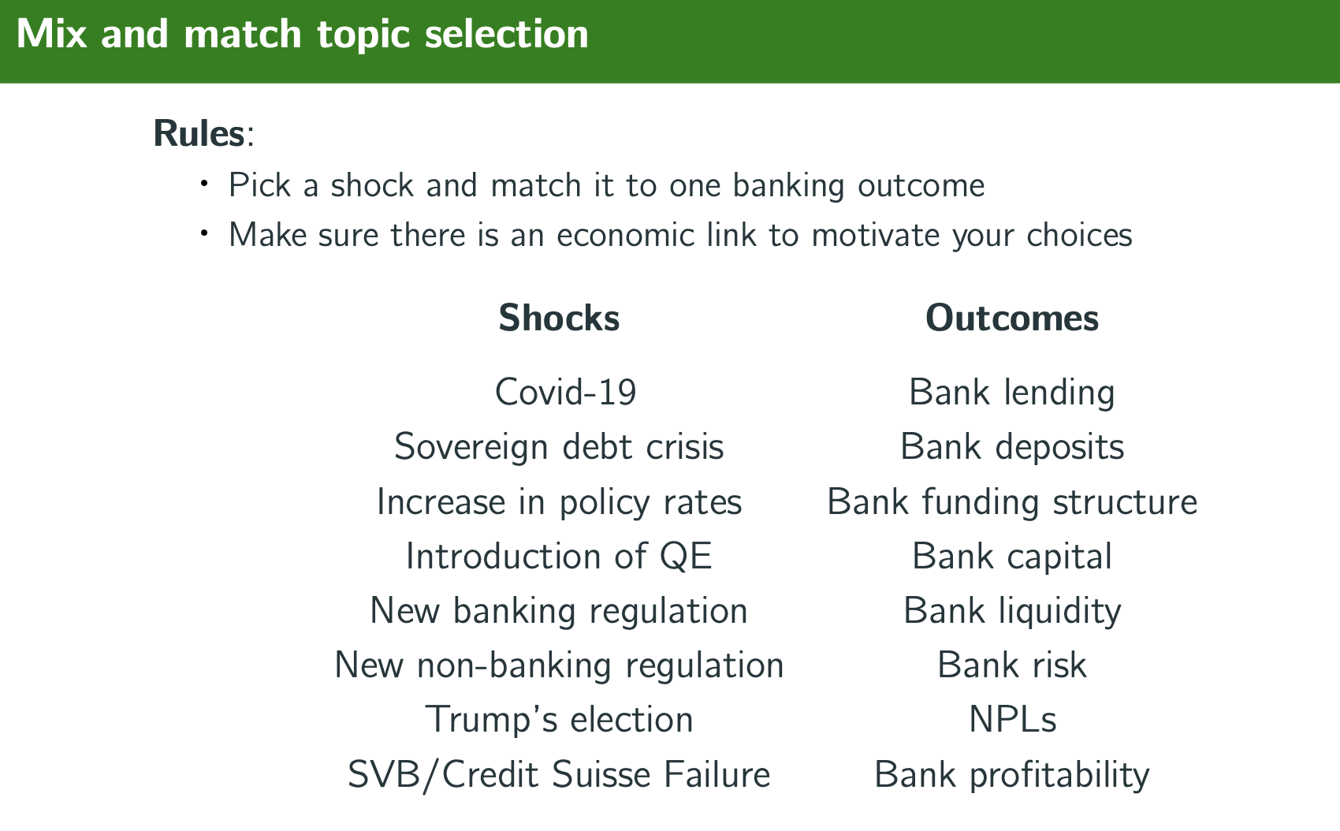
Other Notes:
- Top academic newspapers: Journal of financial intermediation; JMCB, MS, QJE, Econometrical, Review of Economic Studies, America Economic Review; Journal of Finance, Journal of Financial Economics, Review of Financial Studies, Review of Finance
- Top conferences: American Economic Association, American Finance Association, European Finance Association Meetings, International Banking Economic and Finance Association, CEPR-BIS-Gerzensee Conference in Financial Intermediation

- AI Tools: Elicit, Connected Papers, Litmaps
- Dataset: you can also use own data but more cumbersome, worth looking at topics that can easily be addressed by current dataset (mostly)
- No abstract needed, as we only have 15pp available

Paper Structure
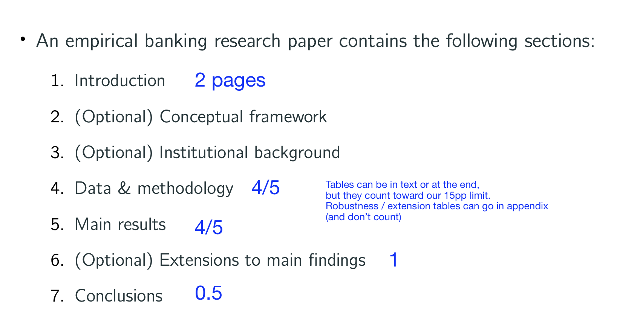

Presentation Structure


